1. **SCOPE**

The purpose for this SOP is to provide instructions for the use of the CSSP Report Writer Helper application. This application will create report ‘templates’ in .csv, .docx, .xlsx and .kml that can be used to generate reports in the CSSP Webtools.

1. **REFERENCES**

CSSP Webtools: <http://wmon01dtchlebl2/>

CSSP Report Writer Helper application documents

1. **PROCEDURE**

3.1. Install the CSSP Report Writer Helper application found here:

\\Atlantic.int.ec.gc.ca\shares\Branches\EPB\ShellFish\CSSP_Code\CSSPReportWriterHelper_Install

Or

\\int.ec.gc.ca\SHARES\M\MQEM_NATIONAL\CSSP_Code\latest\CSSPReportWriterHelper_Install

3.2 Overview of application:

The first time the application runs, a new directory will automatically be created on your computer in the C-drive; (C:\CSSPReportTemplates\). This is the location where the templates you will create will be saved. When the application opens it will look like the image below*. [To make life easier to re-open the application I have created a shortcut of the CSSPReportWriterHelper.application and pasted it to my desktop.]*

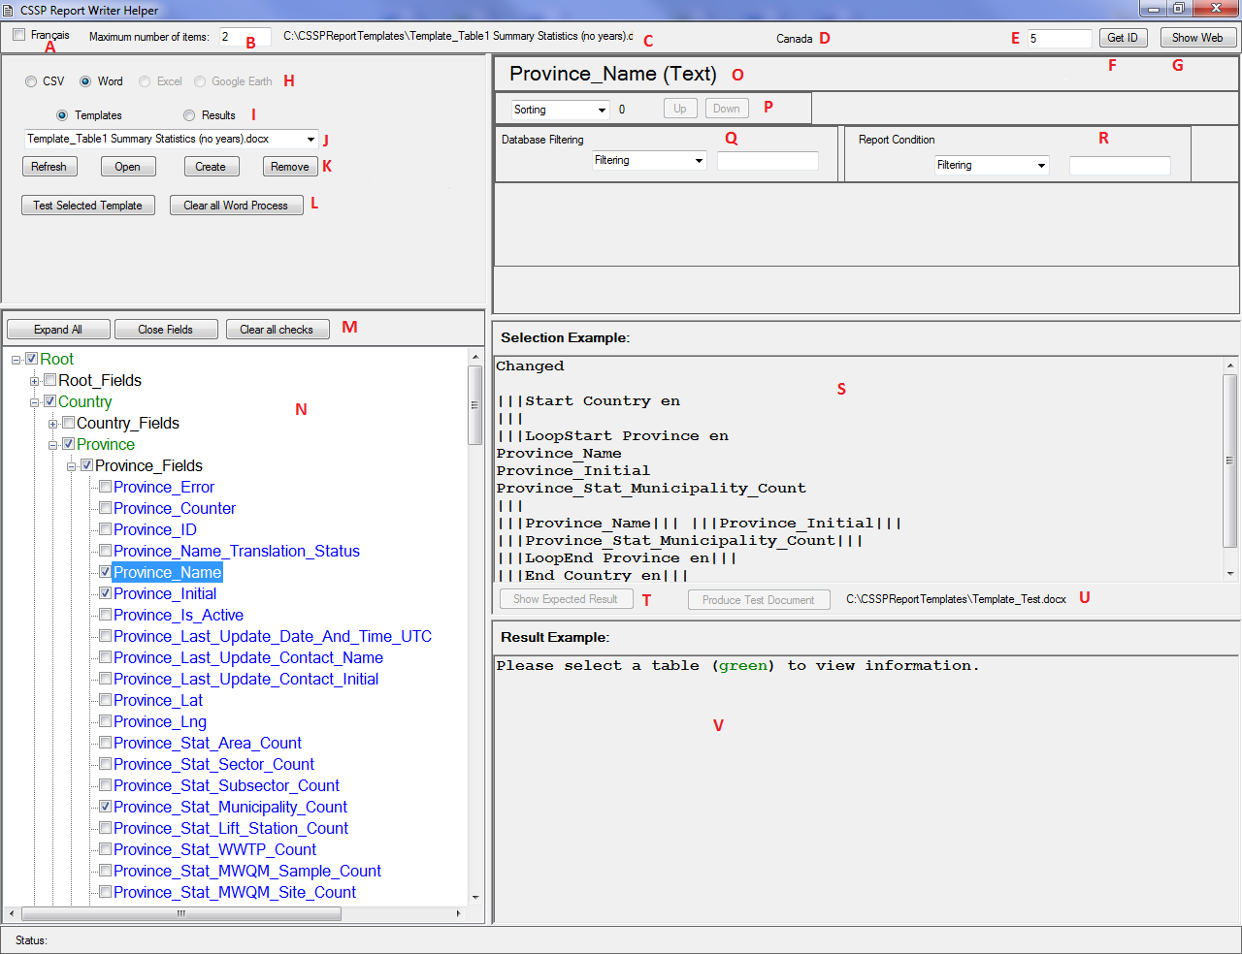

A – Select Language

B – Maximum number of item that will appear in your results window (lower right)

C – File name of the currently selected template

*D-G* – *Are related and allow you to select the level of your query. If you’re at the top level of the database; Canada, you can query any data entry within the country, but not in USA! If you’re at the Province level of NB you can’t query other provinces. You would have to be at the country level. If you’re at a subsector level; you can query all data below but, you will not be able to query sector level. The way that I operate these buttons is: select G and Webtools appears; select the area you want to query, i.e. Canada. Then reselect G and close this window. Select ‘F’ and the code for Canada appears (‘E’), and the name ‘D’ appears!!*

D – Name of the CSSPWebTools page related to this query (E)

E – Number of the CSSPWebTools page related to this query

F – Button (Get ID) to select the CSSPWebTools page ID

G – Button (Show/Hide Web) to show or hide the CSSPWebTools site

H – Document template you want to create (.csv, .docx, .xlsx, .kml)

I – Stored Template or Result files

J – Listing of the files above (C:\CSSPReportTemplates\)

K – File manipulation buttons

L – Button to test the current template you are building and button to clear (close) all open Word documents.

M – Buttons to help manage and view database fields (this is backbone of Webtools)

N – List of hierarchical database fields *[when you look at this database just think about how Webtools is displayed. If I want to look at North America then I have to be at the ‘Root’ level. If want to look at Canada; then ‘Country’ and if I want to look at NB then ‘Province’. If I want to look at a particular WQ site then I have to go down to ‘MWQM_Site”. The entry point to query each of these segments of data is highlighted in Green!! Important for later in discussion]*

O – Current data selection from database. Once you highlight a dataset like ‘Country name’ it will appear.

P – Options to sort the dataset that appears in ‘O’

Q – Options to filter dataset that appears in ‘O’

R – Report filtering/condition section

S – As you build your query the Template programming automatically show you what you are requesting*. [Remember that in order to see this you must be on the ‘green’ button that we spoke of in ‘N’ above! You can also change heading etc. while in this box – that’s for later]*

T – Button to test the template that you just created (in ‘S’) (test results will be shown in V) and button to produce the same test but with an external document.

U – Name of the template you want to use

V – Result(s) section showing results and/or errors. *[This is helpful to remind you that you might be at a ‘subsector’ level when you’re asking to query provinces! That won’t work! You can query subsector by selecting any ‘green’ button higher in the database, but not vice versa!!]*

3.2.1 More detail on the Top row of options

Top row, left part



Top row, right part

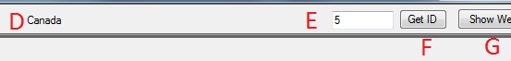

**A - Français checkbox:** Used to produce French templates.

**B - Maximum number of items:** Allow you to set the number of ‘rows’ that will be shown in your example. Too large of a number can be a long process

and potentially produce an error of type (**ServerError: The remote server returned an error: (500) Internal Server Error.)**

**C-** **Selected file name:** Shows selected template.

**D,E,F,G - Location Text:** (before the Get ID box). At first, this area along the upper bar is empty. So go to upper right and select ‘Show Web’. Select an area of concern (a province perhaps) from Webtools. Select ‘Hide Web’ in upper right to go back to ReportWriter and then select ‘Get ID’ button ‘E’. The number and Area name will appear.

*Example: If you are at the ‘All Locations’ and then you click ‘Get ID” the number 1 will appear. If you move down to Area NB-01 and click ‘Get ID’ then the number 554 appears.*

3.2.2 More Detail on the Second section;

Second section of options allows you to select the template file type you want to create and allows you to name the file, test it or select it from your stored templates on your c:\ drive.

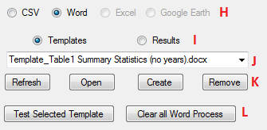

**H -Document type radio button:** At this time only the .CSV and MS Word formats are available. These .csv files are easily imported using Excel or other applications which can read .csv files. .csv 🡪 comma-separated values.

**I - Template and Results radio button:** The Template radio button is used to show all the template files, while the Results radio button show all the results files located under C:\CSSPReportTemplates\ for the given document type.

**J - Drop down:** List of all the Templates or Results files.

**K - Refresh Button:** Refreshes the list of files in the drop down list.

**Open Button:** Opens the selected file for editing or viewing.

**Create Button:** Creates a new Template document.

**Remove Button:** Removes/deletes the selected document.

**L - Test Selected Template Button:** Use to view the results of the selected template. For .csv format the results will also appear in lower right window of application helper. For Word format the result document will automatically be opened so you can quickly view your test/template result.

**Clear all Word Process:** Clear/close all word documents.

3.2.3 More detail on third section:

Third section of options includes sorting or filter tools.

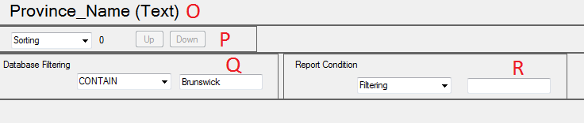

**O- Selected field name:** Shows the name of the selected field and data type. All fields from the database (except for field ending with ‘_Counter’) can be sorted and filtered both on the database side and the reporting side.

**P- Sorting drop down:** Used to sort (Ascending or Descending) the selected field. In this case, it will be ascending.

**Sorting priority number:** The number just beside the sorting drop-down is the sorting priority number and it is used to sort one field before or after another. The user can use the Up or Down button to change the sorting priority.

**Up or Down button:** The user can use the Up or Down button to change the sorting priority.

**Q - Database Filtering:** The user can filter the database request by using the Database Filtering section. This filtering mechanism changes depending on the type of information the selected field contains. This section actually changes the information received from the database. (more later…) NOTE: Although the application only show one filtering per field you can add as many filtering as you need. (EX: Province_Name CONTAIN Br START New END ick)

**R - Report Condition:** The user can also use the report condition section to show or hide the information received from the database in various parts of the report/document. This filtering mechanism changes depending on the type of information the selected field contains (more later…) *NOTE: Although the application only show one filtering per field you can add as many filtering as you need. (EX: Province_Name CONTAIN Br START New END ick)*

3.2.4 More detail on right side – bottom windows:

Middle and bottom right section allow you to see the template coding that you are building and the results.

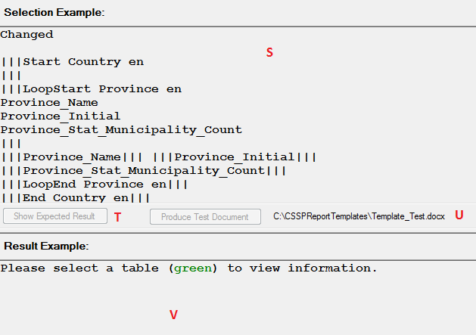

**S - Template text box: (Text with |||S):** Example of a template. The user can copy/paste this text into a template (word) and then run the template with the application. The three lines ‘III’ just indicate the start and finish of a segment of database request.

**T - Test button:** Clicking on the test button would create the results of New Brunswick and display it in section ‘V’

**- Produce Test Document:** Clicking the test button would create the results of New Brunswickand display it in a separate document (word).

**U - Template file name:** A file with the specified name will be created or replaced under C:\CSSPReportTemplates\. A result file is also created or replaced by removing the “Template_” within the template file name.

**V - Result text box:** Shows results of template and also messages and/or errors.

3.2.5 Details of database:

Bottom left section of options – the database.

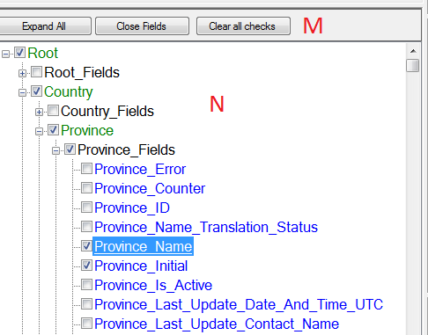

**M - Expand all button:** Use to expand the tree view so the user can see all tables and fields.

**Close Fields button:** Use to hide/close all fields within the tree view.

**Clear all checks button:** Use to remove all previously selected items.

**N – Database tree view:** A hierarchical representation of database. *[The green buttons are the top or entry to each data segment. You must select these colored buttons to test your template]*

3.3 How to create a template – step by step (simple example, see 3.6 for complexe)

In this example, we will create a template to generate a report that has all the active sampling stations of a specific subsector as well as their description and coordinates (Lat and Long).

The level required in this example would be **Subsector.** So remember that Webtools must be in a subsector to allow the search to work properly. If Webtools is at an Area or a Sector, an error will occur with your template.

* Click on the ‘**Show Web’** button to view Webtools :<http://wmon01dtchlebl2/csspwebtools/>
* Navigate to any Subsector level information ex: NB-06-020-002
* Click on the ‘**Get ID’; 635** appears in the text box and the written description next to it.
* Click on ‘**Hide Web’** to return to the CSSPReportWriterHelper app
* Select your language
* Indicate the ‘**Maximum number of items’** to be returned in you template results. Type in 5.
* Select the template type you would like to create**; .CSV or Word.**
* You can create a template file by clicking on the **‘create’** button. This will open a separate window and allow you to create an empty file into which you will paste your template code. You can also open an existing template. There maybe code in an existing file but this can be deleted and new coding entered.
* Next you can select the data you want to query by checking each box beside the data title. You can expand the fields or close them by selecting the radio button. If you want to restart your selection you can clear previously selected fields.
* In our example, you would scroll down to ‘Subsector_Fields’ highlighted in green and select the ‘+’ box to expand the dataset. Select ‘Subsector_Name_Long’. Next you would select ‘MWQM_Site’ in green and expand this dataset. Select MWQM_Site_Fields’. Check the ‘MWQM_Site_Is_Active’, ‘MWQM_Site_Name’, ‘MWQM_Site_Lat’ and ‘MWQM_Site_Lng’.
* If you want to sort or filter the requested fields, you can select the field by clicking on the field name. The name appears in the top right filtering-sorting window. If you already have it selected you might have to un-click and then

reselect the field name to see the Sorting and Filtering section. The title shows which type of data you have selected or choices that you have for filtering. This portion of the application will be changing depending on the type of Field selected. In our example, we will filter the ‘MWQM_Site_is_Active’. The ‘sorting’ option is changed to ‘ASCENDING’ and we select ‘TRUE’ under Database filtering.

* *NOTE: The database is divided into sections. At the top of each section is a name highlighted in (green). To see the template programming that you have requested you must highlite the green label button. You must also select the green button when you want to ‘test’ your template.*
* Select the Subsector (green) table label in the database. If you are already on the Subsector table label or changing your query you might have to click away then back on the Subsector table name to refresh the template example. When you select the green label the template programming automatically appears in the right middle box. If you keep the green label highlighted and select the Show Expected   
  Results button within the middle right window the results of your query appears or an error.
* *[Note: For CSV templates, - the first line is the labels from the database. These can be changed to your liking. Ex: changing Subsector_Name_Long to Subsector and Subsector_Stat_MWQM_Site_Count to Site Count. This line is the Heading section that will appear in your Excel table.*
* *Note: the template is divided in to sections that* ***begin and end with ‘III’,*** *or a* ***marker****. You will see* *or* ***loopstart*** *after the marker and also* ***loopend*** *after another* ***|||*** *lower in the template****.*** *Between these markers are the data lines that you have requested. This is what is called an* ***INNER TAG.***

*Once the data is downloaded you will see* ***|||*** *without* ***start or *start*** *. Example* ***||| variable|||.*** *This is a* ***Field Tag****. This will be your results and it is in this line that you will format your final product. More on this later*

* *For Word template, any text and its formatting occurs before the last marker || of the field tag. More on this later.*
* Before sending your template to <http://wmon01dtchlebl2/csspwebtools/> for others to use, you should test the template by clicking on the ‘Produce Test Results’ Button.
* Any formatting errors will be detected before trying to access the database. The errors will be shown on the bottom right portion of the application (Result

Example Box) for CSV document type while for Word document type the errors are inserted within the document as comments.

* One special case to note: If you set the ‘Maximum number of items’ to a large number (e.g. 300), it can happen that you would receive an error such as: ServerError: The remote server returned an error: (500) Internal Server Error. This is happening because the CSSPReportWriterHelper is accessing the CSSPWebTools database information via HTTP request. In this case you should reduce the maximum number of items to a smaller number (e.g. 20) and retest it. This particular problem does go away when the template is uploaded to the <http://wmon01dtchlebl2/csspwebtools/> . The production of reports from templates in Webtools accesses the database directly (therefore no server limitation).
* Once your satisfied with your Expected Results, Open the template file your created. Go to the middle right window, highlite the code and hit Control C. Copy the code into the template file using Control V. Make sure that there is a ‘return’ after your last line of code. Just place cursor at end of last row and click the keyboard Enter Button. If you forget to do this step an error may appear.
* All template files are automatically stored in C:\CSSPReportTemplates\ directory.
* You can then upload the template created to any Subsector type page in this example by using the File tab. See section 3.5.
* Once the template is uploaded for one particular subsector, all other subsectors will have access to the same template.

3.4 Importing templates into CSSP Webtools

Once you have completed a template you will need to import it into the CSSP Webtools in order to generate reports. Once a template is uploaded, it can be used by all users to generate reports.

3.4.1 Open CSSPWebtools and navigate to the database level that you were in when you created the template (i.e. Subsector). This is very important. You must import the template in the file tab of the appropriate level. Example: If your template is for a report showing all tide stations for each **province**, then you need to upload the template under the **‘File tab’ of a specific province**. The template will then be available for all provinces.

3.4.2 Click on the edit button and then on the add button  to open the Upload File section as shown below:

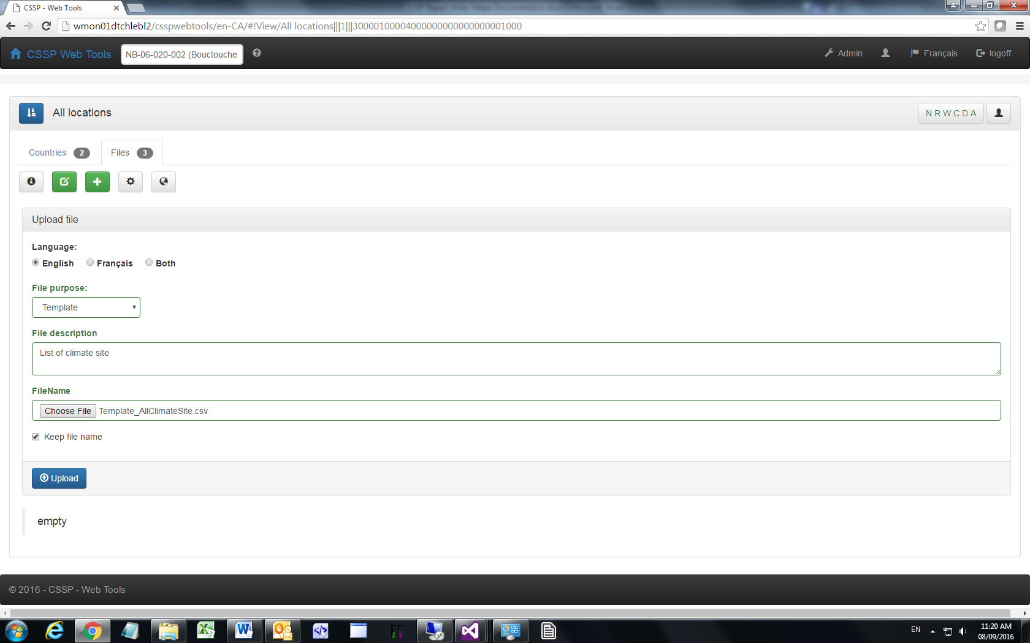

3.4.3 Fill in all the appropriate fields (Language, file purpose – template in this case, File description).

3.4.4 Select the file to upload (Note: has to be the same type). Next, click on the upload button.

3.4.5 To generate a report using the template you have just imported, click on the generate button . You can download and view the report by clicking on the edit button  and then on the download button  next to the file you want to view. You can save and view this document on your computer. You can also delete and edit these files.

3.5 How to create a template – step by step (complex example)

In this example, we will create a template to generate the Table 1 in our annual and reclassification reports.

The level required in this example would be **Subsector.** So remember that Webtools must be in a subsector to allow the search to work properly. If Webtools is at an Area or a Sector, an error will occur with your template.

* Click on the ‘**Show Web’** button to view Webtools :<http://wmon01dtchlebl2/csspwebtools/>
* Navigate to any Subsector level information ex: NB-06-020-002
* Click on the ‘**Get ID’; 635** appears in the text box and the written description next to it.
* Click on ‘**Hide Web’** to return to the CSSPReportWriterHelper app
* Select your language
* Indicate the ‘**Maximum number of items’** to be returned in you template results. Type in 5.
* Select the template type you would like to create**; Word.**
* You can create a template file by clicking on the **‘create’** button, or type the file name of text box, Open an existing template.
* Next you can select the data you want to query by checking each box beside the data title. You can expand the fields or close them by selecting the radio

button. If you want to restart your selection you can clear previously selected fields.

* In our example, you would scroll down to ‘Subsector_Fields’ and select the ‘+’ box to expand the dataset. Select ‘Subsector_Name_Long’ (check box) it and then click on the GREEN SUBSECTOR (you will see the information added on the middle right screen).
* Next you would scroll down and expand ‘MWQM_Site_Fields’. Check the ‘MWQM_Site_Name’, MWQM_Site_Is_Active. Click on the MWQM_Site_Is_Active again (on the name, don’t uncheck the box) and then select on the top right screen: Sorting = Ascending. Do the same for the MWQM_Site_Name but click ‘Sorting : Ascending’ on the top right screen. Next click on the GREEN MWQM_SITE and then on the GREEN SUBSECTOR (you will see the information added on the middle right screen).
* Now you need to continue checking the desired boxes. Go back in the ‘MWQM_Site_Fields’ list and check the;

MWQM_Site_Stat_GM_30_Samples, MWQM_Site_Stat_Median_30_Samples, MWQM_Site_Stat_P90_30_Samples, MWQM_Site_Stat_P90_Over_43_30_Samples, MWQM_Site_Stat_Min_FC_30_Samples, MWQM_Site_Stat_Max_FC_30_Samples,

MWQM_Site_Stat_Min_Year_30_Samples, (skip this one if you don’t want the period column in your table)

MWQM_Site_Stat_Max_Year_30_Samples, (skip this one if you don’t want the period column in your table)

MWQM_Site_Stat_Sample_Count_30_Samples

* Next click on the GREEN MWQM_SITE and then on the GREEN SUBSECTOR (you will see the information added on the middle right screen). At this point you can click on the on the Test button on the middle right screen to see if you have any errors (there should be any if you followed all the steps above).
* Next click on the ‘Open button’ (make you sure have selected the template that you named at the start. Copy and Paste all the text/code from the middle right column into your **word document and create at the bottom a table** with the appropriate titles. Once you are done, it should look like bellow:

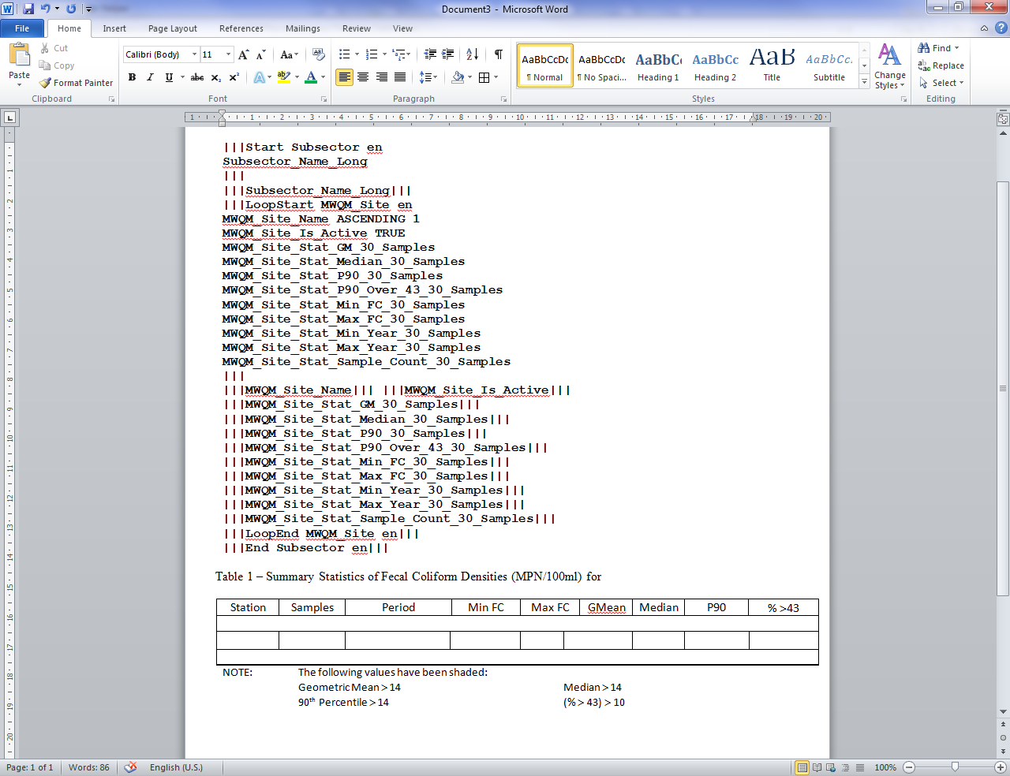

* Next you need to put the text in the appropriate rows and column. Make sure you save your progress as you go. First off, you can select all the text and change the font and size to what you want it to be in your final table. Let’s select ‘Calibri’, 12 pts and not bold.
* The first information you should cut and paste is the 4th line of text ‘**|||Subsector_Name_Long’.** Cut and paste this next to your title.
* In the second row of your table (under your column titles) you need to cut and paste all the information in between the ‘Loop Start’ tag (including the |||) and the ||| at the end of the first MMWQM_Site_Stat_Samples_Count_30_Samples. Make sure you leave a return (a.k.a.: enter) at the very end.
* Next cut and paste the ‘LoopEnd’ line in the very last row of your table. Leave a return at the end.
* Next cut and paste the very last line of text ‘End Subsector end’ under your table. When you are done these steps, it will look like this:

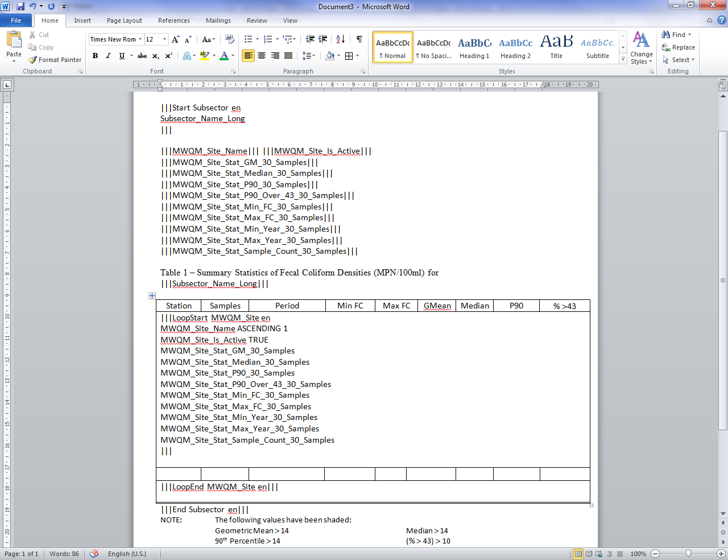

* Next you need to cut and paste the last lines of text into the appropriate columns (3rd line of your table). The fist column you will cut and paste the **|||MWQM_Site_Name|||** line, the next column you will cut and paste the **|||MWQM_Site_Stat_Sample_Count_30_Samples|||** line, the next column you will cut and paste **|||MWQM_Site_Stat_Min_Year_30_Samples|||** add a ‘ **–** ‘ and add right after **the |||MWQM_Site_Stat_Max_Year_30_Samples|||** line. Continue until you have added all the information in the appropriate columns. Center the information in the columns. When you are done, it should look like this:

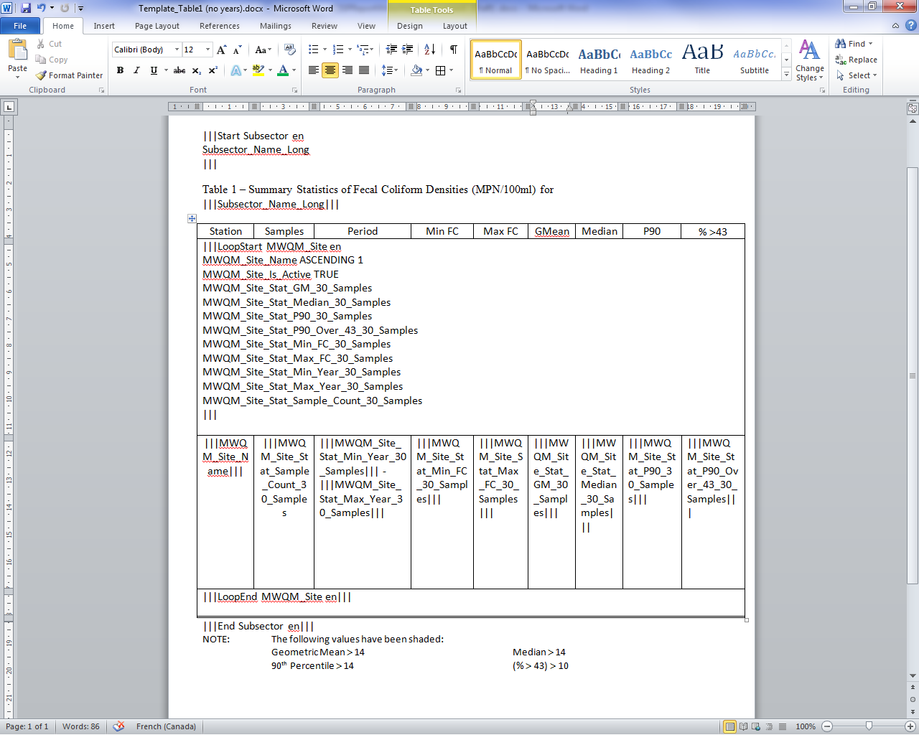

* At this point, you can save your template and test it with the application by clicking on ‘Test Selected Template’. A word document will open up and all the variables (text/code) in your table will be replaced with the appropriate information from the database. If there are any errors (sometimes a space or enter is missing) , there will be an error message indicating what the error is. If there is an error, you will need to close the

word document that popped up, go in the application and open your template and correct it there, save and re-test your template.

* Now all that is left is to put the different formatting and filtering you want for each column. One thing you will notice in your test gives you numbers with multiple numbers after period (4.88 instead of 5). To fix this, write **FORMAT F0** between the last word in the column you want to change and the **|||** of that column. (Example: **|||MWQM_Site_Stat_P90_Over_43_30_Sample|||** becomes **|||MWQM_Site_Stat_P90_Over_43_30_Samples FORMAT F0|||** ). Do this for every column you want to change the format of the data. There are different format options/code that are described in other WI (Format template and discussion).
* To highlight in yellow our usual values (example: median > 14). You need to use the word/code **BIGGER 14.5** and highlight that whole text in yellow and then copy the whole text again in the same column but this time put ‘SMALLER 14.6’ and don’t highlight that. When you are done with this in each column, it will look like this :

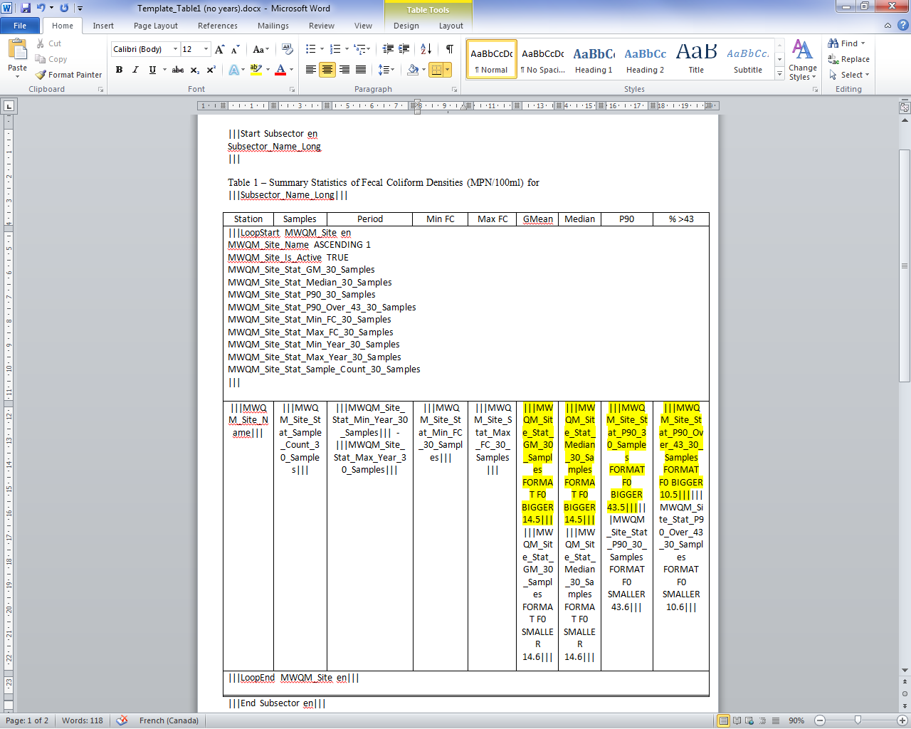

* You can save and test your template and see if you have any errors. If not, you can select the whole 3 row, go in ‘Table properties’, ‘Row’ and in size put ‘0.6’ and select ‘Exactly’. This will hide some of the text but will adjust the height of your result table. You can also remove the column separation lines (except for the first column). It will look like this :

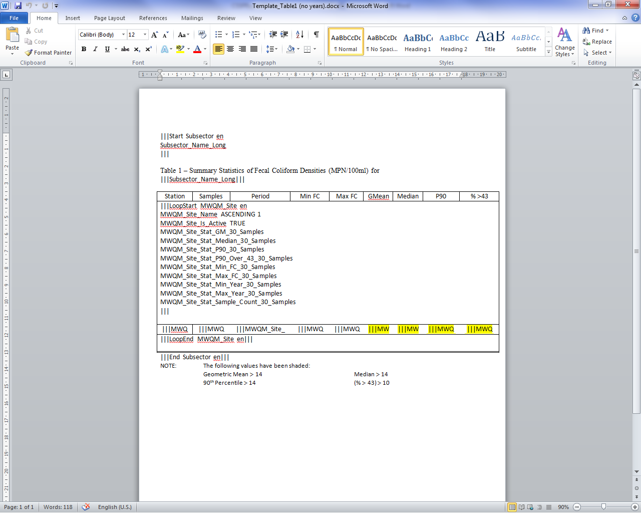

* You now have created the exact table 1 that we have in our current reports. You can upload this in the Webtools for everyone to use in ANY subsector by following the steps in section 3.4.

3.6 Appendix: Template structure:

**Template structure:** Although the CSV template type can be created entirely just by clicking on the proper fields, sorting and filtering, Word template types, with its style, formatted text, tables, etc..., does require a more in-depth knowledge on the various parts of a template.

Below is a template that will be used to provide you with an understanding of the programming symbols that you see in the report writer.

|  |  |
| --- | --- |
| Line | Text |
| 1  2  3  4  5  6  7  8  9  10  11  12  13  14  15  16  17  18  19  20  21  22 | |||Start Root en  Root_Name  |||  |||LoopStart Country en  Country_Name ASCENDING 1 CONTAIN Canada  |||  Below you will find the list of Provinces:  |||LoopStart Province en  Province_Name ASCENDING 1  Province_Lat FORMAT F3 BIGGER 40.3  Province_Lng  |||  Province: |||Province_Name START New|||  Coordinates: |||Province_Lat BIGGER 45.2|||,|||Province_Lng SMALLER -55.4|||  |||ShowStart Province en  Province_Name END land  |||  Special Province |||Province_Name|||  |||ShowEnd Province en|||  |||LoopEnd Province en|||  |||LoopEnd Country en|||  |||End Root en||| |

3.6.1 Legend/Description

* ***Marker:*** *|||*
* ***Tag:*** *Everything between a pair of markers*
  + *Example – line 4,5,6*
    - *|||Loop Country en*
    - *Country_Name ASCENDING 1 CONTAIN Canada*
    - *|||*
* ***Fields:*** *Line (2) or Line(5) or Lines(9,10,11)*
  + *Note: fields can also contain sorting, formatting and filtering*
* ***Start Tag:*** *Tag starting with |||Start*
* ***Loop Tag:*** *Tag starting with |||LoopStart*
* **Show Tag:** Tag starting with |||ShowStart
* **End Start Tag:** Tag starting with |||End
* **End Loop Tag:** Tag starting with |||LoopEnd
* **End Show Tag:** Tag starting with |||ShowEnd
* **Inner Tag:** All text between a Start, LoopStart or ShowStart tag and its associated end tag. Line (7) or Lines(13 and 14)
* **Field Tag:** see example on line 13 – |||Province_Name START New|||
* **Sorting:** see example on line 5 – ASCENDING 1
* **Formatting:** see example on line 10 – FORMAT F3
* **Filtering:** see example on line 5 – CONTAIN Canada
* **Item:** database information composed of one of multiple fields

3.6.2 Template Logic and Checking

* *All templates must have at least one Start Tag*
  + *(CSV) file – only one*
  + *(Word, Excel, Google Earth) more than one if needed*
* *Start Tags cannot be embedded (within another Start Tag)*
* *Start Tag gets only one item from the database which will have the ID equal Startup ID*
* *Start Tag must have a matching End Tag*
  + *|||Start Root en … will need an end tag |||End Root en…*
* *LoopStart Tag need to be within a Start Tag or another LoopStart Tag*
* *LoopStart Tag will get the items from the database up to the maximum number of items specified by the user*
* *LoopStart Tag must have a matching LoopEnd Tag*
  + *|||LoopStart Province en …will need an end tag |||LoopEnd Provice en…*
* *All Field Tags used within the Inner Tag must be identified as a Field within the Start or Loop Tag*
* *The checking of the Template will also force you to remove all Fields not used within the Inner Tag*
* *Misspelled Tags will be identified*
* *Unused Tags will be identified*
* *Misspelled Sorting,Formatting or Filtering will be identified*
* *Wrong number of parameter – value for Sorting, Formatting and Filtering will be identified*
* *Sorting should always be before, Formatting and Filtering on Fields*
* *Formatting should always be before Filtering on Fields*
* *Special Case (CSV templates)*
  + *First line must contains the same number of header text separated by commas as the number of Fields identified within all the Start and Loop Tags*
  + *Can only have one Start Tag*
  + *Can only have one LoopStart Tag under the Start or other LoopStart Tags*
  + *All Fields within the template are automatically flattened into a single row of information*
  + *All Inner Tag text is automatically removed*

***Sorting allowable terms: (see line 5)***

* *ASCENDING, DESCENDING plus the priority setting*
  + *On line 5 the number 1 after ASCENDING is used to set the priority of sorting. The lower the number the higher the priority. The example below would start by sorting Field2 then sort Field1.*
    - *Ex:*
    - *Field1 ASCENDING 2*
    - *Field2 ASCENDING 1*

***Formatting: (see line 5)***

* *FORMAT plus format string*
  + *On line 10 the F3 after FORMAT is used to format the Province_Lat with 3 digits after the decimal*

***Filtering allowable terms:***

* *Text: CONTAIN, START, END, EQUAL, BIGGER, SMALLER*
  + *Examples:*
  + *Field1 CONTAIN Canada*
  + *Field1 CONTAIN Can CONTAIN Canada*
  + *Field1 START C END a*
  + *Field1 CONTAIN New*Brunswick*
    - *Special case * will be replaced with a space*
* *Number: EQUAL, BIGGER, SMALLER*
  + *Examples:*
  + *Field1 BIGGER 34*
* *Date: EQUAL, BIGGER, SMALLER (With variables YEAR, MONTH, DAY, HOUR, MINUTE)*
* *True or False: TRUE, FALSE*
  + *Examples:*
  + *Field1 TRUE*
* *Enumeration: EQUAL*
  + *Examples:*
  + *Infrastructure_Infrastructure_Type EQUAL WWTP*

Other important documents:

* CSSPReportWriterHelper document Sorting (Draft).docx
* CSSPReportWriterHelper document FORMAT date (Draft).docx
* CSSPReportWriterHelper document FORMAT number (Draft).docx
* CSSPReportWriterHelper document Filtering (Draft).docx

1. **MAINTENANCE**

For any additional troubleshooting help (errors or bugs), please contact Charles LeBlanc (charles.leblanc2@canada.ca). For general questions, contact your local CSSP working group committee member.